**CYCLE-5**

**2.** **Program to find maximum of three numbers using AWT.**

**PROGRAM**

private void button1ActionPerformed(java.awt.event.ActionEvent evt) {

int n1,n2,n3;

n1 = Integer.parseInt(textField1.getText());

n2 = Integer.parseInt(textField2.getText());

n3 = Integer.parseInt(textField3.getText());

if(n1 > n2 && n1> n3)

{

textField4 .setText(""+n1);

}

else if (n2 > n1 && n2> n3)

{

textField4 .setText(""+n2);

}

else

{

textField4.setText(""+n3);

}

**OUTPUT**

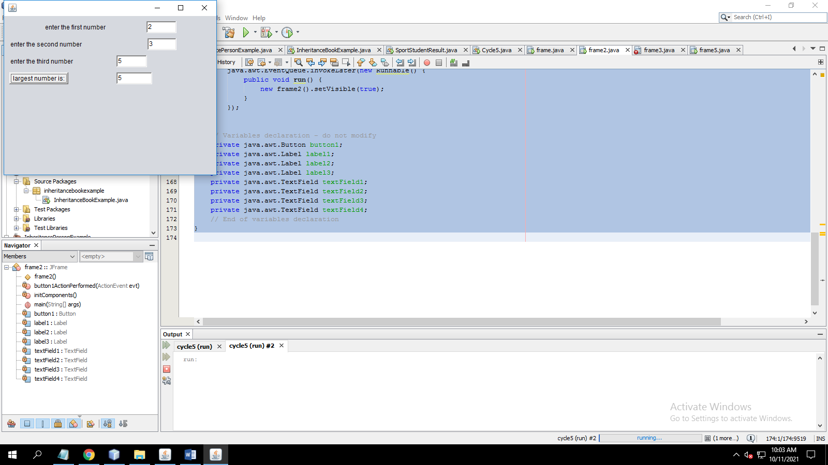

**3. Find the percentage of marks obtained by a student in 5 subjects. Display a happy face if he secures above 50% or a sad face if otherwise**

**PROGRAM**

float a ,b, c,d,e,percnt,avg ;  
     a=Integer.parseInt(textField1.getText());  
     b=Integer.parseInt(textField2.getText());  
     c=Integer.parseInt(textField3.getText());  
     d=Integer.parseInt(textField4.getText());  
     e=Integer.parseInt(textField5.getText());  
     avg=(a+b+c+d+e)/500;  
     percnt=avg*100;  
     label6.setText(""+percnt);  
     ImageIcon image1;  
     if(percnt>50){  
         image1=new ImageIcon("C:\\Users\\Default\\Desktop\\happy.jpg");  
     }else{  
         image1=new ImageIcon("C:\\Users\\Default\\Desktop\\sad.jpg");  
     }  
     jLabel1.setIcon(image1);

**OUTPUT**

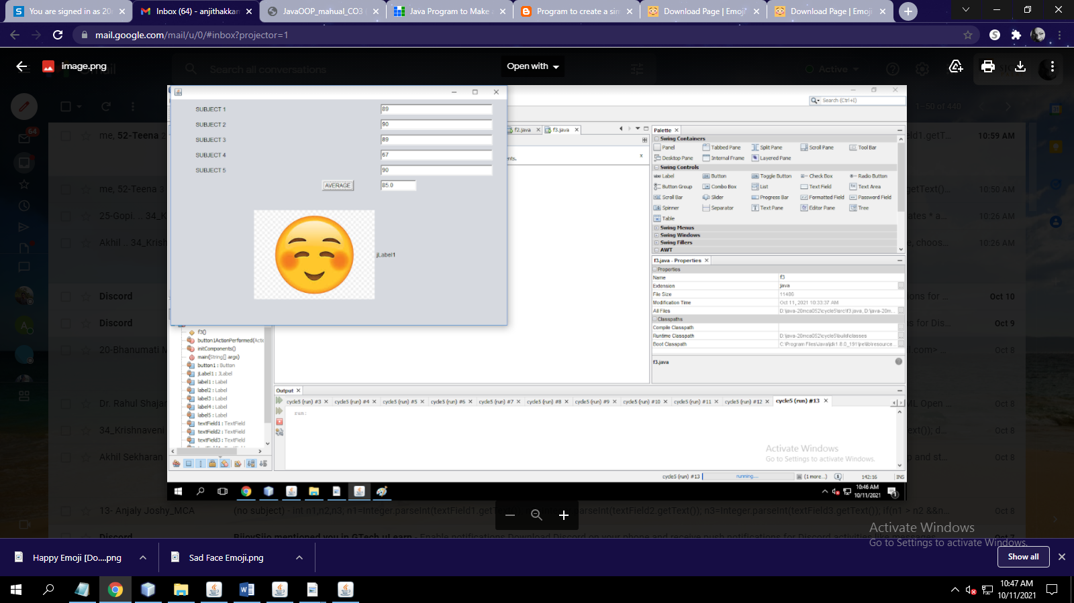

**4.Using 2D graphics commands in an Applet, construct a house. On mouse click event, change the color of the door from blue to red**.

**PROGRAM**

package c4;

import java.applet.*;

import java.awt.*;

import java.awt.event.*;

public class samplehouse extends Applet implements MouseListener {

Color color = Color.blue;

public void init()

{

addMouseListener(this);

}

public void paint(Graphics g)

{

int [] xCoords = { 40, 250, 460 };

int [] yCoords = { 200, 50, 200 };

super.paint(g);

g.drawRect(80, 200, 330, 260);

g.drawPolygon(xCoords , yCoords , 3);

g.setColor(this.color);

g.fillRect(190, 330, 100, 130);

}

public void mouseClicked(MouseEvent e)

{

this.color = color.red;

this.repaint();

}

public void mouseEntered(MouseEvent e) {}

public void mouseExited(MouseEvent e) {}

public void mousePressed(MouseEvent e) {}

public void mouseReleased(MouseEvent e) {}

}

//addMouseListener(new MouseEventListener());

}

**OUTPUT**

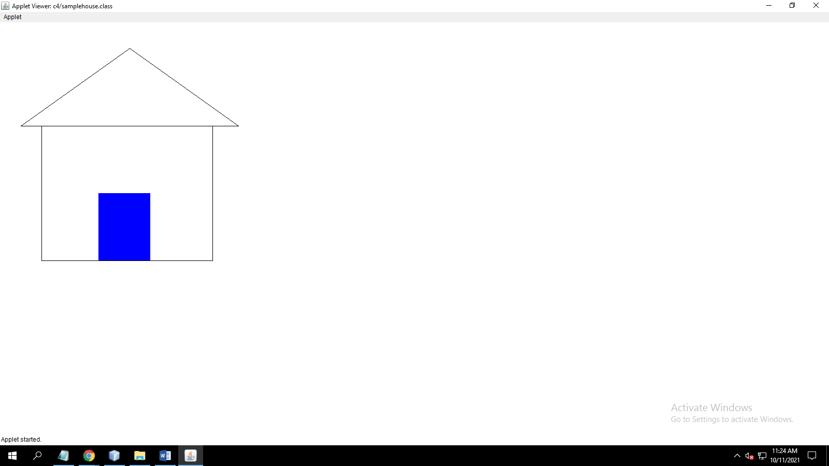

**5. Implement a simple calculator using AWT components.**

**PROGRAM**

int a ,b, add;

a=Integer.parseInt(textField1.getText());

b=Integer.parseInt(textField2.getText());

add =a+b;

textField3.setText(""+add); // TODO add your handling code here:

}

private void button2ActionPerformed(java.awt.event.ActionEvent evt) {

int a ,b, SUB;

a=Integer.parseInt(textField1.getText());

b=Integer.parseInt(textField2.getText());

SUB =a-b;

textField3.setText(""+SUB); // TODO add your handling code here:

}

private void button3ActionPerformed(java.awt.event.ActionEvent evt) {

int a ,b, MUL;

a=Integer.parseInt(textField1.getText());

b=Integer.parseInt(textField2.getText());

MUL =a*b;

textField3.setText(""+MUL); // TODO add your handling code here:

}

private void button4ActionPerformed(java.awt.event.ActionEvent evt) {

int a ,b, DIV;

a=Integer.parseInt(textField1.getText());

b=Integer.parseInt(textField2.getText());

DIV =a/b;

textField3.setText(""+DIV); // TODO add your handling code here:

}

**OUTPUT**

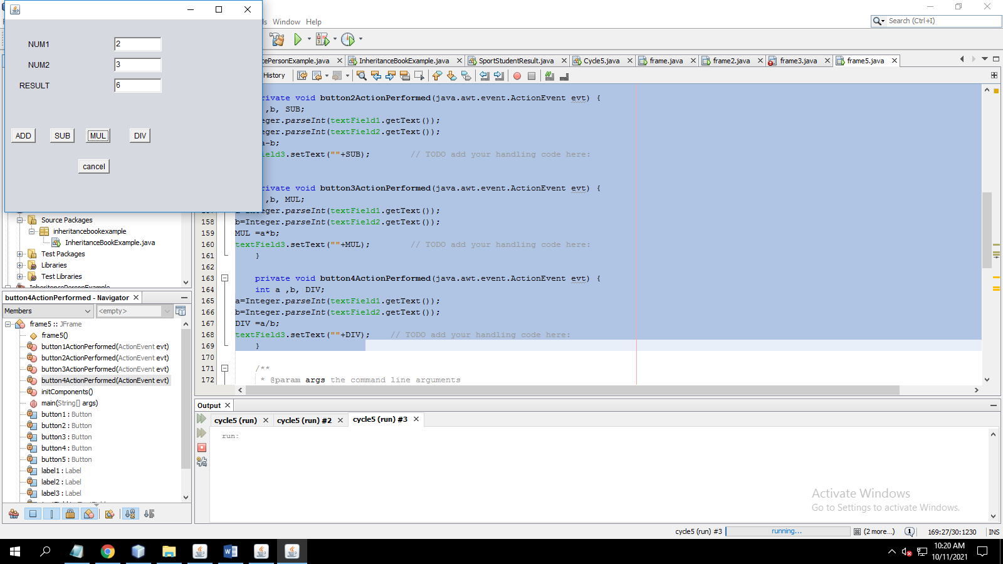

**Or**

int num1=0,num2=0,flag=0; //gdeclared as global

// number 1

textField1.setText(textField1.getText() + &quot;1&quot;);

//number2

textField1.setText(textField1.getText() + &quot;2&quot;);

// number 3

textField1.setText(textField1.getText() + &quot;3&quot;);

//number4

textField1.setText(textField1.getText() + &quot;4&quot;);

// number 5

textField1.setText(textField1.getText() + &quot;5&quot;);

//number6

textField1.setText(textField1.getText() + &quot;6&quot;);

// number 7

textField1.setText(textField1.getText() + &quot;7&quot;);

//number8

textField1.setText(textField1.getText() + &quot;8&quot;);

// number 9

textField1.setText(textField1.getText() + &quot;9&quot;);

//number0

textField1.setText(textField1.getText() + &quot;0&quot;);

//Clear C

textField1.setText(&quot;&quot;);

// +

flag=1;

num1=Integer.parseInt(textField1.getText());

textField1.setText(&quot;&quot;);

// -

flag=2;

num1=Integer.parseInt(textField1.getText());

textField1.setText(&quot;&quot;);

// *

flag=3;

num1=Integer.parseInt(textField1.getText());

textField1.setText(&quot;&quot;);

// /

flag=4;

num1=Integer.parseInt(textField1.getText());

textField1.setText(&quot;&quot;);

// =

int sum,sub,mul,div;

num2=Integer.parseInt(textField1.getText());

if(flag == 1)

{

sum=num1+num2;

textField1.setText(&quot;&quot;+sum);

}

else if(flag == 2 )

{

sub=num1-num2;

textField1.setText(&quot;&quot;+sub);

}

else if(flag == 3)

{

mul=num1*num2;

textField1.setText(&quot;&quot;+mul);

}

else if(flag == 4)

{

div=num1/num2;

textField1.setText(&quot;&quot;+div);

}

else

{

textField1.setText(&quot;&quot;);

}

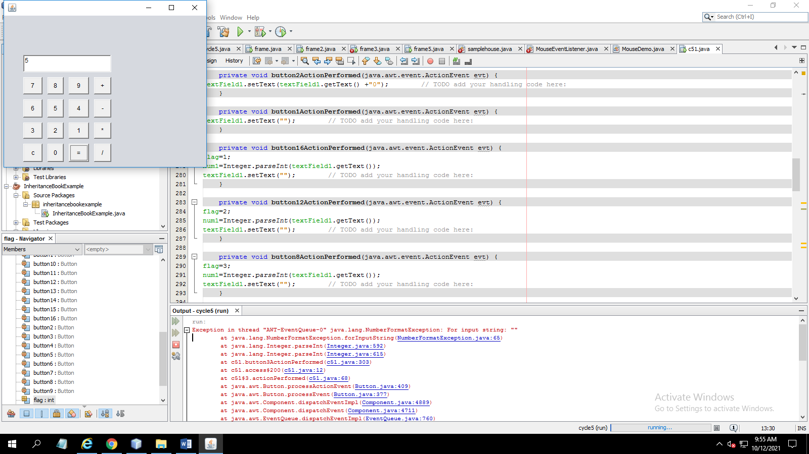

**7.** **Develop a program to handle all mouse events and window events**

**PROGRAM**

package c6;

import java.awt.*;

import java.applet.*;

import java.awt.event.*;

/*<applet code="MouseDemo" width=300 height=300>

</applet>*/

public class MouseDemo extends Applet implements MouseListener,MouseMotionListener

{

int mx=0;

int my=0;

String msg="";

public void init()

{

addMouseListener(this);

addMouseMotionListener(this);

}

public void mouseClicked(MouseEvent me)

{

mx=20;

my=40;

msg="Mouse Clicked";

repaint();

}

public void mousePressed(MouseEvent me)

{

mx=30;

my=60;

msg="Mouse Pressed";

repaint();

}

public void mouseReleased(MouseEvent me)

{

mx=30;

my=60;

msg="Mouse Released";

repaint();

}

public void mouseEntered(MouseEvent me)

{

mx=40;

my=80;

msg="Mouse Entered";

repaint();

}

public void mouseExited(MouseEvent me)

{

mx=40;

my=80;

msg="Mouse Exited";

repaint();

}

public void mouseDragged(MouseEvent me)

{

mx=me.getX();

my=me.getY();

showStatus("Currently mouse dragged"+mx+" "+my);

repaint(); }

public void mouseMoved(MouseEvent me)

{

mx=me.getX();

my=me.getY();

showStatus("Currently mouse is at"+mx+" "+my);

repaint();

}

public void paint(Graphics g)

{

g.drawString("Handling Mouse Events",30,20);

g.drawString(msg,60,40);

}

}

**OUTPUT**

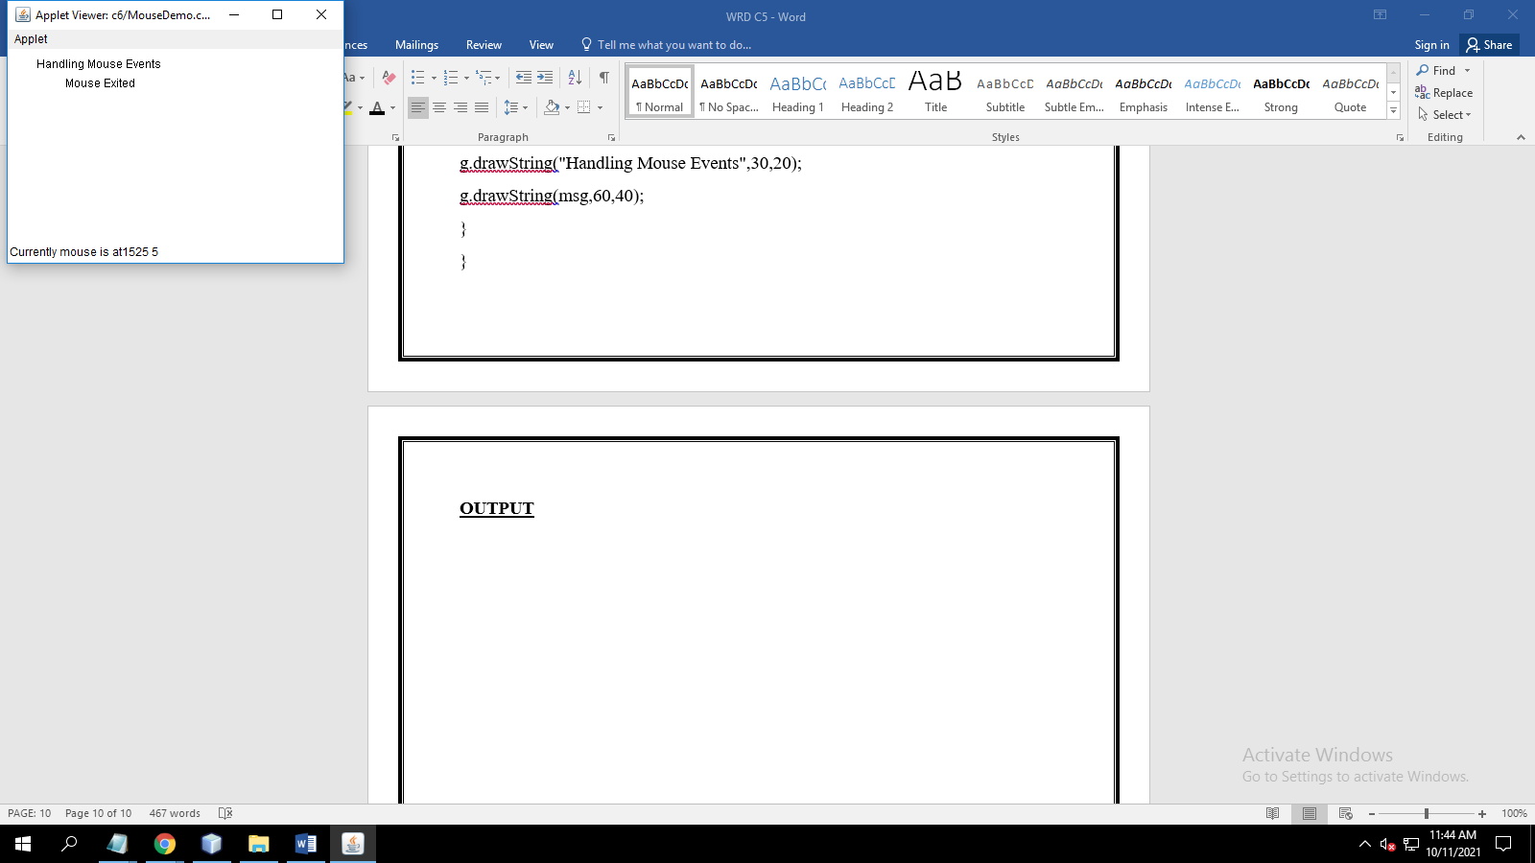

**8. Develop a program to handle Key events.**

**PROGRAM**

**OUTPUT**